PROJECT PROGRESS REPORT
PROJECT PROGRESS REPORT
(Reporting No. 09/ 10)
Reporting Period: From 10/08/2026 To 17/09/2026
1. Student Information
Student Name | PATEL MAN VISHNUBHAI.
Enrollment Number | 25IC03CA053
Program/Branch | MCA (CA)/ ICA
Semester | 3
Contact Number | 8849948963
Email ID | 25ic03ca053@ppsu.ac.in

2. Project Details
Type | Research Project
Department/Domain | MCA CA (DS/ML) /AI &ML
Mentor Name | Mr. Srikant Singh
Start Date | 08-06-2026
End Date | 03-10-2026

3. Project Title
- OpenCV - Based System for Crack Identification and Width Estimation

4. Progress During the Reporting Period
A. Previous Reporting Review
Planned Task | Status | Remarks
Complete ZIP Download Functionality | Completed | ZIP Download feature completed and integrated into the project.
Final System Testing and Debugging | Completed | Tested the complete system and resolved identified errors.
Validate Complete Project Workflow | Completed | Verified the workflow from image upload to final report generation.
Fix Remaining Errors and Issues | Completed | Resolved major issues and improved system reliability.
Finalize Project Documentation | Completed | Prepared project documentation, screenshots, and result evidence.
Prepare Final Project Demonstration | Completed | Completed preparation of the final project presentation and demonstration.

B. Work Completed During This Reporting Period
Description:
- Completed the remaining development tasks and finalized the complete project workflow.
- Completed ZIP Download functionality and integrated all project modules.
- Finalized crack detection, width estimation, risk classification, result visualization, and CSV reporting.
- Reviewed relevant research papers and finalized project references.
- Performed final system testing and debugging using multiple crack images.
- Verified the complete workflow and resolved identified issues.
- Successfully generated annotated images, CSV reports, and downloadable ZIP packages.
- Completed final project documentation, screenshots, and demonstration preparation.

C. Evidence / Deliverables Produced
Sr. No. | Deliverable / Evidence | Description / Link / Attachment
1 | Source Code | Completed Python source code with all integrated crack detection and measurement modules.
2 | Screenshots and Model Output | Annotated crack images showing detection, width measurements, and risk classification results.
3 | CSV and ZIP Reports | Generated CSV analysis report and completed ZIP package containing project outputs.
4 | Test Results | Final testing and validation results using multiple crack images.
5 | Research Paper Review | Reviewed research papers related to crack detection, image processing, and crack-width estimation.
6 | SRS / Design Document | System workflow, project methodology, and technical design details.
7 | Project Presentation | Project demonstration materials and presentation preparation.
8. | Project Repository | GitHub: https://github.com/ManPatel448/OpenCV-Based-System-for-Crack-Identification-and-Width-Estimation.git

- Screenshots
measurement_model.py
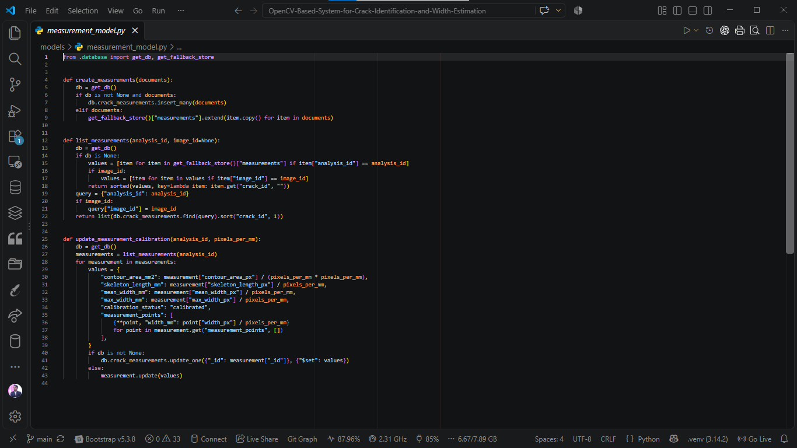
Image_model.py
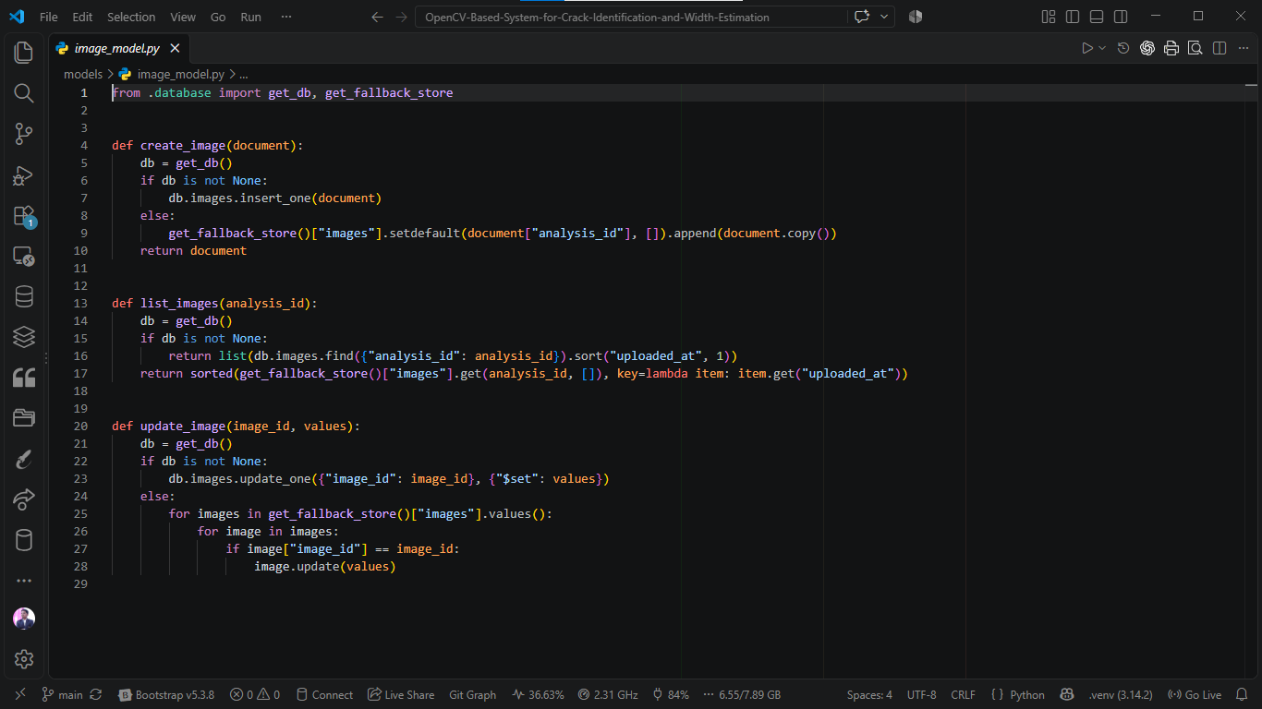
MongoDB Database:
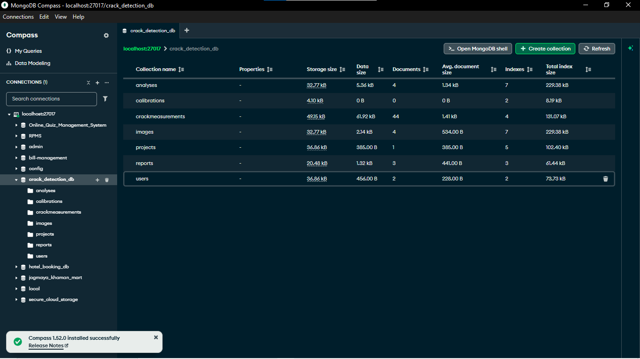

D. Current Project Progress
Overall Project Completion: 97%
Sr. No. | Project Component / Module | Status | Completion (%)
1 | Library Installation | Completed | 100%
2 | Import Libraries | Completed | 100%
3 | Project Configuration | Completed | 100%
4 | Image Upload | Completed | 100%
5 | Image Preprocessing | Completed | 100%
6 | Crack Segmentation | Completed | 100%
7 | Crack Detection | Completed | 100%
8 | Crack Width Estimation | Completed | 100%
9 | Risk Classification | Completed | 100%
10 | Result Visualization | Completed | 100%
11 | CSV Report | Completed | 100%
12 | ZIP Download | Completed | 100%

E. Challenges / Issues Faced
- Faced minor issues during final system integration and testing.
- Encountered challenges in ensuring accurate crack detection under different lighting and image conditions.
- Required parameter adjustments to improve crack-width estimation and measurement consistency.
- Faced file-handling challenges while generating and downloading ZIP packages.
- Resolved errors related to output generation and verified the complete project workflow.
- Completed final testing and improved the overall system reliability.
F. Actions Taken / Solution Implemented
- Optimized OpenCV parameters to improve crack detection and image-processing results.
- Applied pre-processing and morphological operations to reduce noise and improve crack segmentation.
- Verified pixel-to-mm calibration to improve crack-width measurement consistency.
- Implemented debugging and error handling to resolve system issues.
- Improved ZIP file generation and organized output files for easy downloading.
- Performed final testing using multiple crack images and validated all modules.
- Integrated all modules into a complete and reliable project workflow.

G. Plan for Next Reporting
- Prepare the main project documentation with complete system details, methodology, and results.
- Complete the research paper writing based on the project methodology and findings.
- Review and organize research papers, references, and citations.
- Identify and fix minor project bugs to improve system stability.
- Perform final testing and verify all project modules.
- Finalize project screenshots, result analysis, and documentation for submission.
- Prepare the final project presentation and demonstration.

H. Learning / Skills Acquired
- Improved Python programming and OpenCV image-processing skills.
- Gained practical experience in crack detection, segmentation, and width estimation.
- Learned advanced techniques for image calibration, risk classification, and result analysis.
- Improved debugging, testing, and minor bug-fixing skills.
- Developed skills in technical documentation and research paper writing.
- Improved literature review, reference management, and research analysis.
- Gained experience in project maintenance, system integration, and final validation.
- Strengthened technical writing, presentation, and co mmunication skills.

5. Tasks Accomplished
- Completed all major modules of the crack identification and width estimation system.
- Successfully implemented and integrated the ZIP Download functionality.
- Completed final system testing and validation using multiple crack images.
- Verified crack detection, width estimation, and risk classification results.
- Generated annotated images, CSV reports, and downloadable ZIP packages.
- Resolved major integration issues and improved system reliability.
- Organized project outputs and finalized the system workflow.
- Completed the main development phase and started preparing project documentation and research paper work.

6. Tasks in Progress / Next Plan
- Complete the main project documentation with system design, methodology, and results.
- Continue research paper writing based on project implementation and findings.
- Organize research papers, references, and citations.
- Identify and fix minor bugs in the project.
- Perform additional testing to improve system stability and reliability.
- Finalize project screenshots, result analysis, and documentation.
- Prepare the final project presentation and demonstration.

7. Learnings / Skills Acquired
- Improved Python programming and OpenCV image-processing skills.
- Gained knowledge of crack detection, segmentation, and width measurement.
- Developed skills in debugging, testing, and minor bug fixing.
- Improved technical documentation and research paper writing skills.
- Learned effective research analysis and reference management techniques.
- Strengthened problem-solving, project maintenance, and system validation skills.
- Improved technical communication and project presentation skills.

References:
- Bodke, K., Bhirud, S., & Sangle, K. K. (2026). Enhanced Crack Width and Depth Measurement through Binary Image Processing and Geometric Analysis. Scientific Visualization, 18(1), 49–61.
- Ramasamy, L., & Vijayan, P. (2026). Advanced Image Processing and Deep Learning Methods for Automated Crack Detection in Civil Engineering Structures: A Comprehensive Review. Asian Journal of Civil Engineering.
- Deng, J., Singh, A., Zhou, Y., Lu, Y., & Lee, V. C.-S. (2022). Review on Computer Vision-Based Crack Detection and Quantification Methodologies for Civil Structures. Construction and Building Materials, 356, 129238.
Evaluation (To be filled by Mentor)
Criteria | Bloom's Level | Excellent (20) | Good (15) | Average (10) | Poor (5) | Marks
Progress as per Previous Plan | L3–Apply | All planned tasks completed | Most completed | Partial completion | Very little progress
Technical / Research Implementation | L4–Analyze | Excellent implementation with clear evidence | Good implementation | Basic implementation | Insufficient evidence
Quality of Deliverables | L5–Evaluate | High-quality, validated deliverables | Good quality | Acceptable | Poor / incomplete
Problem Solving & Challenges | L4–Analyze | Challenges clearly identified and effectively solved | Most issues addressed | Limited solutions | No clear effort
Planning for Next Phase | L6–Create | Clear, realistic and measurable plan | Mostly clear plan | Basic plan | No proper plan
Documentation & Presentation | L3–Apply | Well-structured and professional | Minor issues | Average clarity | Poor documentation
Total marks out of 100

Evaluation
Student Signature | Mentor (Institute)  Signature

Mentor (Institute) Remarks
________________________________________________________________________________________________________________________________________________________________________________________________________________________________________________________________________________________________________________________________________________________________________________________________________________________________________________________________________________________________________________________________________________________________________________________________________________________________________________________________________________________________________________________________________________________________________________________________________________________________________________________________________________________________________________________________________________________________________________________________________________________________________________________________________________________________________________________________________________________________________________________________________________________________________________________________________________________________________________________________________________________________________

